**Topics: Descriptive Statistics and Probability**

1. Look at the data given below. Plot the data, find the outliers and find out $μ, σ, σ^{2}$

|  |  |
| --- | --- |
| **Name of company** | **Measure X** |
| Allied Signal | 24.23% |
| Bankers Trust | 25.53% |
| General Mills | 25.41% |
| ITT Industries | 24.14% |
| J.P.Morgan & Co. | 29.62% |
| Lehman Brothers | 28.25% |
| Marriott | 25.81% |
| MCI | 24.39% |
| Merrill Lynch | 40.26% |
| Microsoft | 32.95% |
| Morgan Stanley | 91.36% |
| Sun Microsystems | 25.99% |
| Travelers | 39.42% |
| US Airways | 26.71% |
| Warner-Lambert | 35.00% |

Ans: Mean (μ): 33.27

Standard Deviation (σ): 16.37

Variance (σ^2): 268.00

Outliers: 91.36%

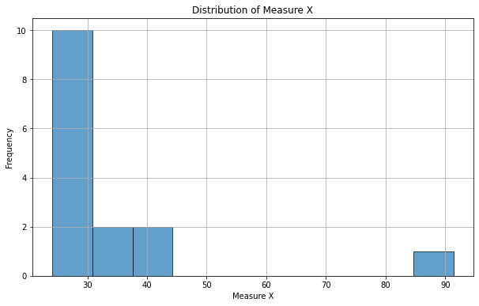



Answer the following three questions based on the box-plot above.

1. What is inter-quartile range of this dataset? (please approximate the numbers) In one line, explain what this value implies.
2. What can we say about the skewness of this dataset?
3. If it was found that the data point with the value 25 is actually 2.5, how would the new box-plot be affected?

Ans: a) IQR = Q3-Q1 = 12-5= 7.

The interquartile range (IQR) is the range of values that resides in the middle of the scores.

b) Given data is right skewed, as there is outlier present in the right side of the boxplot.

c) The median value will remain same, but the interquartile range will change. Moreover there will not have any outlier



Answer the following three questions based on the histogram above.

1. Where would the mode of this dataset lie?
2. Comment on the skewness of the dataset.
3. Suppose that the above histogram and the box-plot in question 2 are plotted for the same dataset. Explain how these graphs complement each other in providing information about any dataset.

Ans:

1. The mode dataset would lie in range of 4 to 8.
2. Given data is Right skewed as the outliers present in the right side of the data.
3. They both are right-skewed and both have outliers the median can be easily visualized in box plot where as in histogram mode is more visible.
4. AT&T was running commercials in 1990 aimed at luring back customers who had switched to one of the other long-distance phone service providers. One such commercial shows a businessman trying to reach Phoenix and mistakenly getting Fiji, where a half-naked native on a beach responds incomprehensibly in Polynesian. When asked about this advertisement, AT&T admitted that the portrayed incident did not actually take place but added that this was an enactment of something that “could happen.” Suppose that one in 200 long-distance telephone calls is misdirected. What is the probability that at least one in five attempted telephone calls reaches the wrong number? (Assume independence of attempts.)

Ans:

We are given that one in 200 calls is misdirected, so the probability of a single call being misdirected (P_misdirected) is:

P_misdirected = 1/200 = 0.005

The probability that a single call is correctly directed (P_correct) is the complement of P_misdirected:

P_correct = 1 - P_misdirected = 1 - 0.005 = 0.995

Since the attempts are independent, we can find the probability that all five calls are correctly directed as:

P(all correct) = P_correct^5 = (0.995)^5

we can find the probability that at least one call is misdirected by taking the complement:

P(at least one misdirected) = 1 - P(all correct)

= 1- (0.995)^5

≈ 0.0247

So, the probability that at least one in five attempted telephone calls reaches the wrong number is approximately 0.0247, or about 2.47%.

1. Returns on a certain business venture, to the nearest $1,000, are known to follow the following probability distribution

|  |  |
| --- | --- |
| x | P(x) |
| -2,000 | 0.1 |
| -1,000 | 0.1 |
| 0 | 0.2 |
| 1000 | 0.2 |
| 2000 | 0.3 |
| 3000 | 0.1 |

1. What is the most likely monetary outcome of the business venture?
2. Is the venture likely to be successful? Explain
3. What is the long-term average earning of business ventures of this kind? Explain
4. What is the good measure of the risk involved in a venture of this kind? Compute this measure

Ans:

1. The most likely monetary outcome of the business venture is 2000$ As for 2000$ the probability is 0.3 which is maximum as compared to others
2. The success of the venture depends, if the expected return is positive. To determine this, we'll calculate the expected value (mean) of the probability distribution.

Expected Value (E) = Σ [x * P(x)]

E = (-2,000 * 0.1) + (-1,000 * 0.1) + (0 * 0.2) + (1,000 * 0.2) + (2,000 * 0.3) + (3,000 * 0.1)

E = -200 - 100 + 0 + 200 + 600 + 300

E = 800

The expected value of this venture is $800. Since the expected return is positive, the venture is likely to be considered successful in terms of monetary outcomes.

1. The long-term average is Expected value = Sum (X * P(X)) = 800$ which means on an average the returns will be + 800$